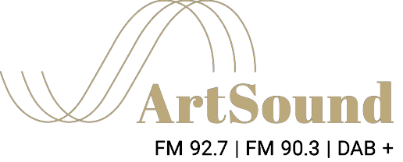
ArtSound FM 92.7 | 90.3 | DAB+
Cnr NSW Crescent and Manuka Circle,
Griffith ACT 2603 (next to Manuka Pool)
PO Box 3573, Manuka ACT 2603
admin@artsound.fm
02 6295 7444

