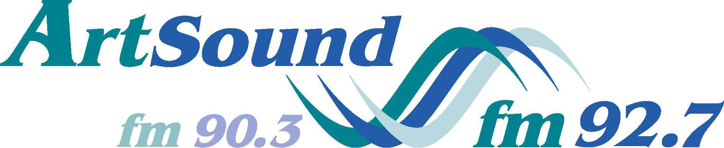

YOUNG VIRTUOSO AWARD 2022
AGREEMENT

Please complete and sign this agreement and submit by 5.00pm on Friday 26 August 2022.

For auditions: a video recording of 3-4 minutes should be forwarded to ArtSound.FM via We Transfer.com or delivered to ArtSound FM Studios in the Manuka Arts Centre, before 5pm on 26th August 2022.
For Finals: The ACT Finals will be held 2-4pm on Sunday, 25 September 2022 in the ArtSound Recording Studio and broadcast live on ArtSound (FM92.7, 90.3 and streamed online at http://www.artsound.org.au/). Each contestant will perform two or more works of their own choice from the classical music repertoire for a total 20 minutes. ArtSound has a Yamaha grand piano. Each contestant will be able to rehearse for 15 minutes at times to be arranged during week prior to Final.

Please mailto:admin@artsound.fm
1. Your biography suitable for a concert program (up to 200 words)
2. Your accompanist’s biography (up to 100 words), where relevant
3. Program details – title(s) of the work(s) to be performed with approximate timings.

Name: __________________________________________________ Date of Birth: ___/___/___
(instrumentalist must be under 25, vocalists under 30 on 31/12/22)

Are you a permanent resident of Australia or New Zealand? YES / NO

Have you lived or studied in the ACT or near surrounds for at least 12 months (by31/12/2022)? YES / NO

Instrument / Voice Type: ____________________________________________________

Address: _______________________________________________________________________
_______________________________________________________ Post Code: _________
Phone: __________________________ Mobile: _________________________
Email: ___________________________________________

Name of Accompanist: ______________________________________________________

I have correctly stated my age. Noting that instrumental contestants must be under 25 years of age and vocal contestants under 30 on 31 December 2022.

Signed: ______________________________
(CONTESTANT)

Print: _______________________________ Date: ___/___/___

If you, the Entrant/Contestant, are under the age of 18 as of 31 December 2022 a Parent or Guardian must also sign this agreement.

Signed: _______________________________
(PARENT OR GUARDIAN)

Print: _________________________________ Date: ___/___/___

